**7 DESIGN**

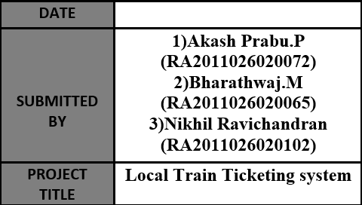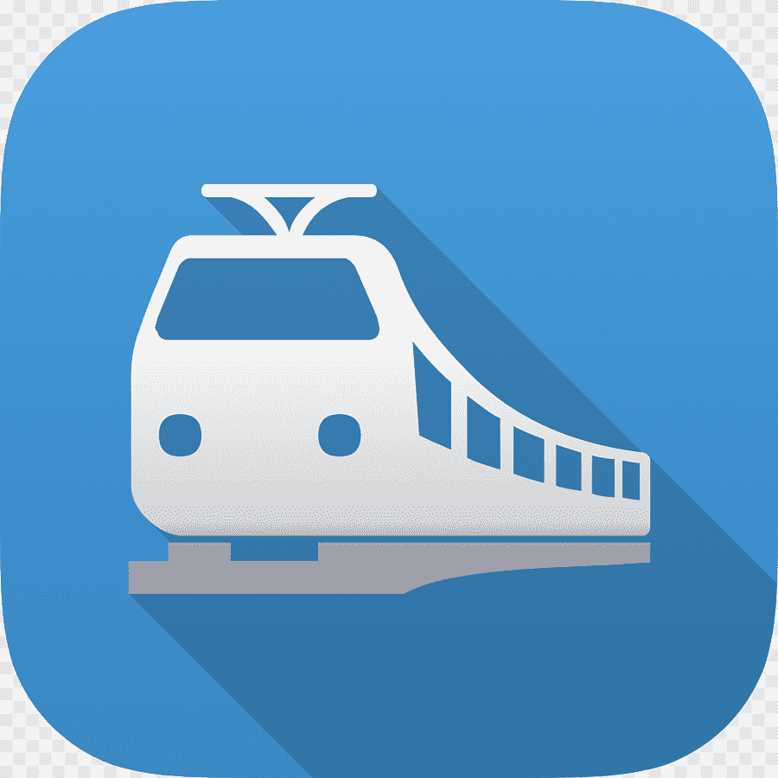

**7.1 SYSTEM ARCHITECTURE**

**System Architecture** is an abstract, conceptualization-oriented, global, and focused to achieve the mission and life cycle concepts of the system.

The purpose of system architecture is to define a comprehensive solution based on principles, concepts, and properties logically related to and consistent with each other.



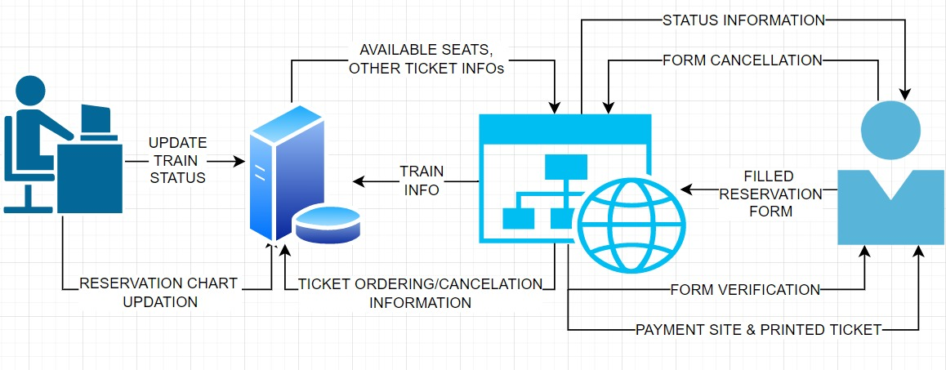

**8 MODELLING UML USECASE DIAGRAM &**

**CAPTURING USECASE SCENARIOS**



**8.1 USE CASE DESCRIPTION**

**USE CASE DIAGRAM:**

The purpose of a use case diagram in UML is to demonstrate the different ways that a user might interact with a system.

**USE CASE SYMBOLS AND NOTATION:**

The notation for a use case diagram is pretty straightforward and doesn't involve as many types of symbols as other UML diagrams.

**1] SYSTEM:**

A specific sequence of actions and interactions between actors and the system. A system may also be referred to as a scenario.

**2] USE CASES:**

Horizontally shaped ovals that represents an action which accomplishes some sort of task within the system.

* 1. **3] ACTORS:**

Stick figures that represent the people actually employing the use cases. It should be placed outside the system.

There are two types of Actors namely:

* 1. • **PRIMARY ACTOR:** Initiates the use of the system. It should be placed on the left side of the system.
  2. • **SECONDARY ACTOR:** It is more reactionary and should be placed on the right side of the system.
  3. **4] RELATIONSHIPS:**
  4. • **INCLUDE:** This shows the dependency between base and included use case (it happens every time).
  5. • **EXTENT:** This happens only when certain criteria are met.

**5] ASSOCIATION:**

A line between actors and use cases. In complex diagrams, it is important to know which actors are associated with which use cases.

**8.2 USE CASE DIAGRAM**

